1. Add new product into the system
2. Steps:

|  |  |
| --- | --- |
| Actor | System |
| 1. Choose command “Add Product”   Main Screen: | 1. Display “Add Product” screen:   Add Product Screen: |
| 1. Input data then click “Add” button   “Add Product” screen with data: | 1. Display “Add Product Confirmation” screen above “Add Product” screen:   “Add Product Confirmation” screen: |
| 1. Click on “OK” button | 1. Display “Main” Screen |

1. Add new product with duplicate ID
2. Steps:

|  |  |
| --- | --- |
| Actor | System |
| 1. Choose command “Add Product”   Main Screen: | 1. Display “Add Product” screen:   Add Product Screen: |
| 1. Input data then click “Add” button   “Add Product” screen with data: | 1. Display “Duplicate Product ID” screen above “Add Product” screen   “Duplicate Product ID” screen: |
| 1. Click on “OK” button | 1. Display “Add Product” screen with invalid ID |
| 1. Input valid ID and click “Add” button   “Add Product” screen with valid ID: | 1. Display “Add Product Confirmation” screen above “Add Product” screen   “Add Product Confirmation” screen: |
| 1. Click on “OK” button | 1. Display “Main” Screen |

1. Add new customer into the system
2. Actor: Customer
3. Steps:

|  |  |
| --- | --- |
| Actor | System |
| 1. Choose command “Add Customer”   Main Screen: | 1. Display “Add Customer” screen:   Add Customer Screen: |
| 1. Input data then click “Add” button   “Add Customer” screen with data: | 1. Display “Add Customer Confirmation” screen above “Add Customer” screen:   “Add Customer Confirmation” screen: |
| 1. Click on “OK” button | 1. Display “Main” Screen |

1. Add new customer with no name
2. Actor: Customer
3. Steps:

|  |  |
| --- | --- |
| Actor | System |
| 1. Choose command “Add Customer”   Main Screen: | 1. Display “Add Customer” screen:   Add Customer Screen: |
| 1. Input data then click “Add” button   “Add Customer” screen with no name: | 1. Display “Empty Customer Name” screen above “Add Customer” screen   “Empty Customer Name” screen: |
| 1. Click on “OK” button | 1. Display “Add Customer” screen with the same data and no name |
| 1. Input a name and click “Add” button   “Add Customer” screen with valid data: | 1. Display “Add Customer Confirmation” screen above “Add Customer” screen   “Add Customer Confirmation” screen: |
| 1. Click on “OK” button | 1. Display “Main” Screen |

1. Record purchase from customer into the system
2. Actor: Customer
3. Steps:

|  |  |
| --- | --- |
| Actor | System |
| 1. Choose command “Add Purchase”   Main Screen: | 1. Display “Add Purchase” screen:   Add Purchase Screen: |
| 1. Input data then click “Add” button   “Add Purchase” screen with data: | 1. Display “Add Purchase Confirmation” screen above “Add Purchase” screen:   “Add Purchase Confirmation” screen: |
| 1. Click on “OK” button | 1. Hide “Purchase Confirmation” and Display “Receipt” screen:   “Receipt” screen: |
| 1. Click on “OK” button | Display “Main” Screen |

1. Input invalid Product ID
2. Actor: Customer
3. Steps:

|  |  |
| --- | --- |
| Actor | System |
| 1. Choose command “Add Purchase”   Main Screen: | 1. Display “Add Purchase” screen:   Add Purchase Screen: |
| 1. Input a product ID that does not exist in the store   “Add Purchase” screen with invalid product ID: | 1. Display “Invalid Product ID” error message   “Invalid Product ID” screen: |
| 1. Hide “Invalid Product ID” screen and show “Add Purchase” screen with invalid Product ID. Input valid data and click the “Add” button   “Add Purchase” screen with valid data: | 1. Display “Add Purchase Confirmation” screen above “Add Purchase” screen:   “Add Purchase Confirmation” screen: |
| 1. Click on “OK” button | 1. Hide “Purchase Confirmation” and Display “Receipt” screen:   “Receipt” screen: |
| 1. Click on “OK” button | Display “Main” Screen |

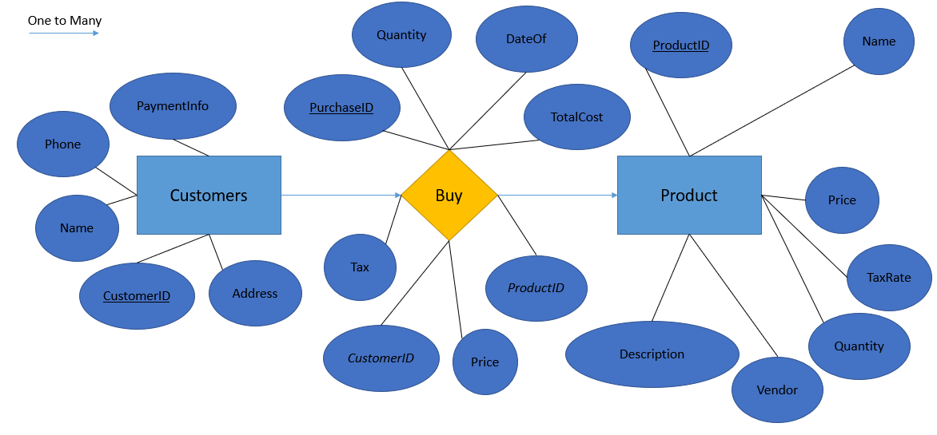

Entity:

Products(**ProductID**, Name, Price, TaxRate, Quantity, Vendor, Description)

Customers(**CustomerID**, Name, Address, Phone, PaymentInfo)

Relationship:

Purchase(**PurchaseID**, *ProductID*, *CustomerID*, Quantity, Cost, TaxCost, TotalCost, DateOf)